NauDia1000

PAT: Ontwerpsdokument

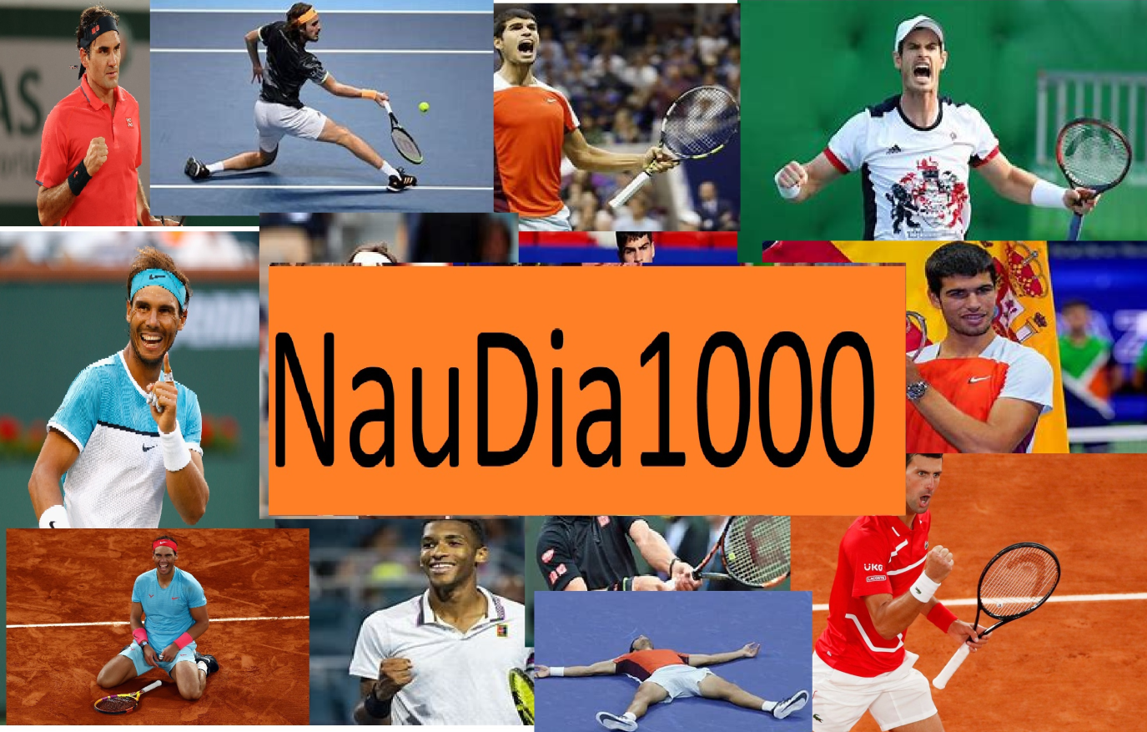

**DIAN NAUDE 18 October 2021**

**Table of contents**

1 TASK 1 6

1.1 A: TAAKDEFINISIE 6

1.2 B: GebruikersVereistes 7

2 Task 2: Databasis-Ontwerp 8

2.1 Relationship 8

2.2 tblPlayers 8

2.2.1 tblPlayers Design View 9

2.3 tblMatches 13

2.3.1 Matches Design View 14

2.4 tblScore 17

2.4.1 Score Design View 1 17

2.4.2 Score Design View 2 18

2.5 tblVenue 20

2.5.1 Venue Design View 20

3 Task 3 23

3.1 A Navigation 23

3.2 B GUI 24

3.2.1 Login 24

3.2.2 User 25

25

3.2.3 Admin 27

3.3 IPO tables 29

4 Task 4 29

4.1 Variables A 29

4.2 Texfiles B 29

4.3 Arrays C 30

**List of Figures**

Figure 1 CaseDiagram 5

# TASK 1

## A: TAAKDEFINISIE

**NAUDIAN1000**

The tennis tournament of 2022 will be held and there is a wide variety of competitors. Each player will receive a chance to compete against every other player(Round robin).The Match will consist out of nine games and the player with the most games in total will win the tournament and the given prize money. Possible scores in a match can be 9-0 or 7-2 etc. If the score reaches 4-4 then a deciding ten point tie breaker will be played to determine the winner.

Each player will be identified by his /her ID. When completing a match the score and given IDs will be received by the program and the next match will be determined. There will be a Male and female tournament where there will be a Male and Female winner

Each result will be stored in the database. When all matches have been played the final results will be determined.

## B: GebruikersVereistes

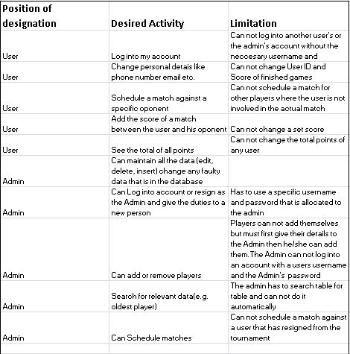

Figure 1 CaseDiagram

# Task 2: Databasis-Ontwerp

## Relationship

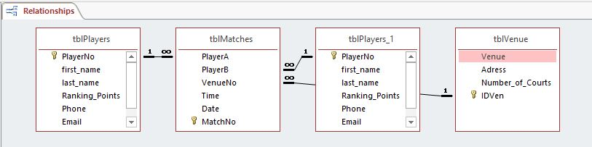

## tblPlayers

All the players information is in this table with PlayerNo identifying each player.

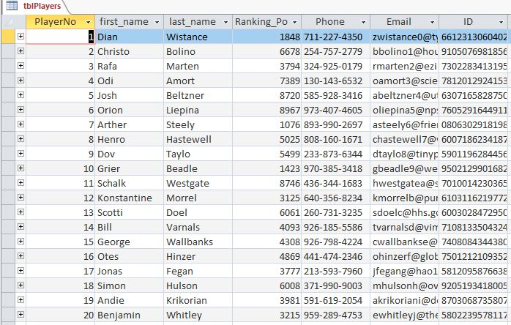

### tblPlayers Design View

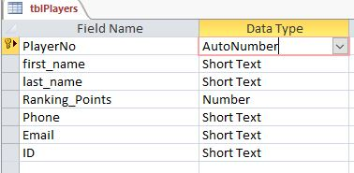

#### PlayerNo

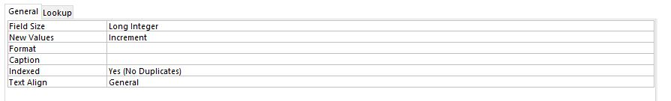

#### First Name

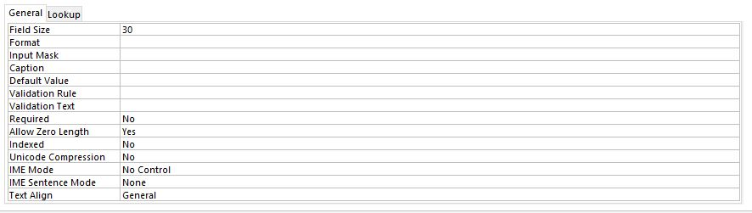

#### Last Name

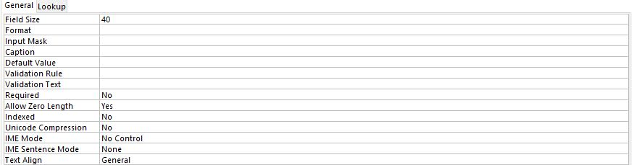

#### Ranking Points

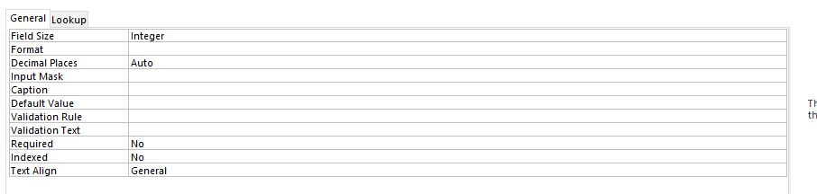

#### Phone

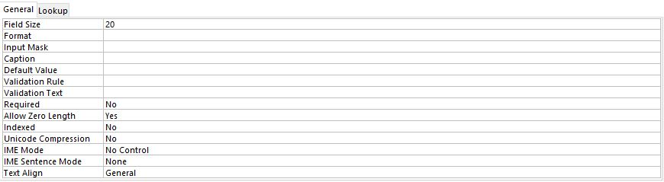

#### Email

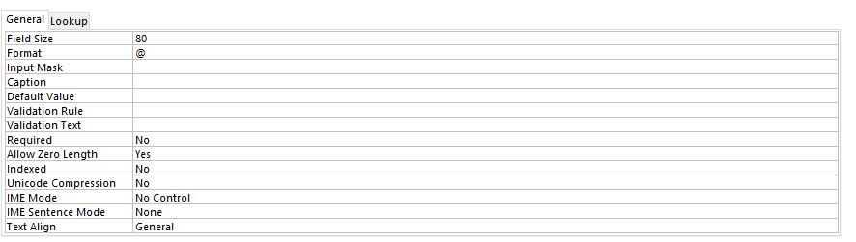

#### ID

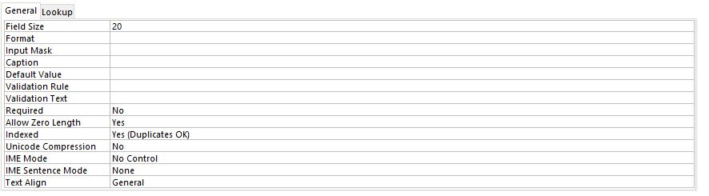

## tblMatches

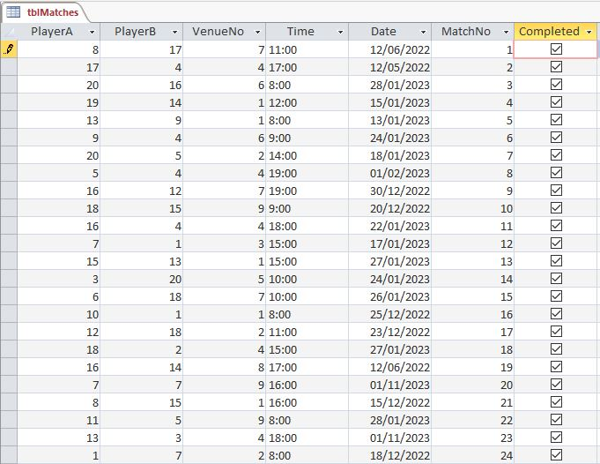

### Matches Design View

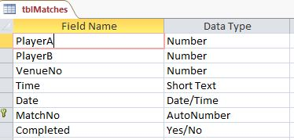

#### Player A + PlayerB + VenueNo

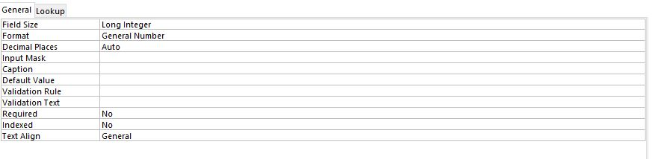

#### Time

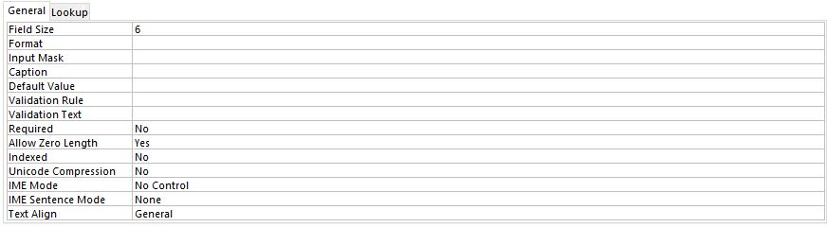

#### Date

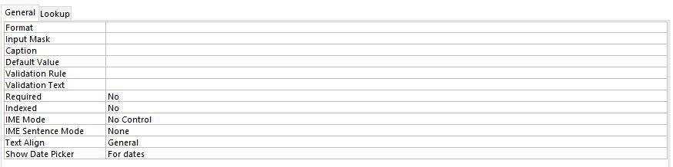

#### MatchNo

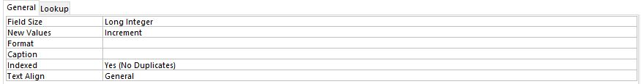

#### Completed

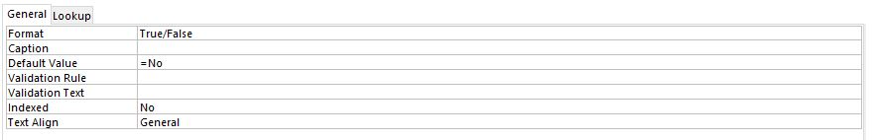

## tblScore

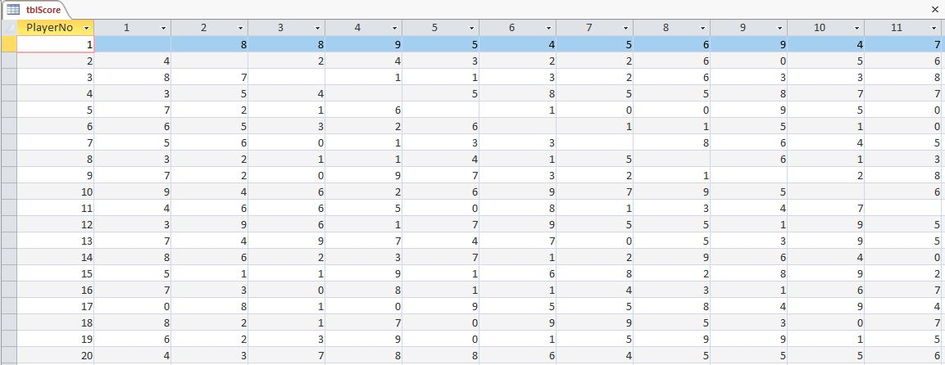

### Score Design View 1

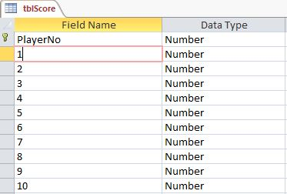

### Score Design View 2

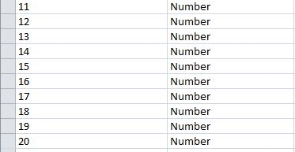

#### PlayerNo

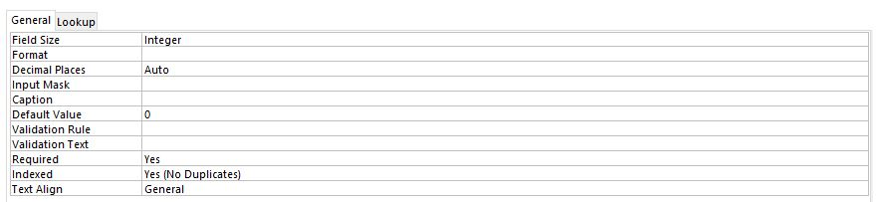

#### Players 1- 20

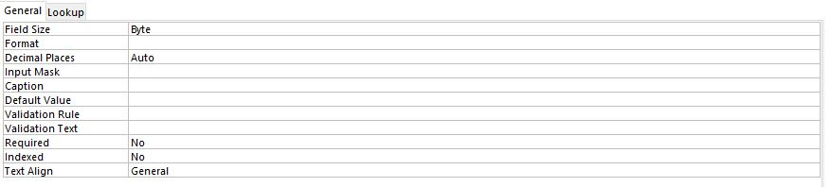

## tblVenue

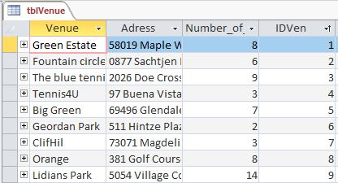

### Venue Design View

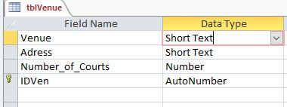

#### Venue

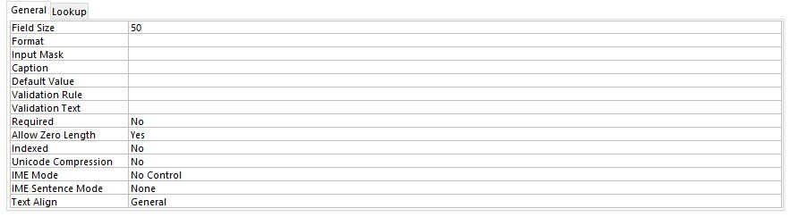

#### Adres

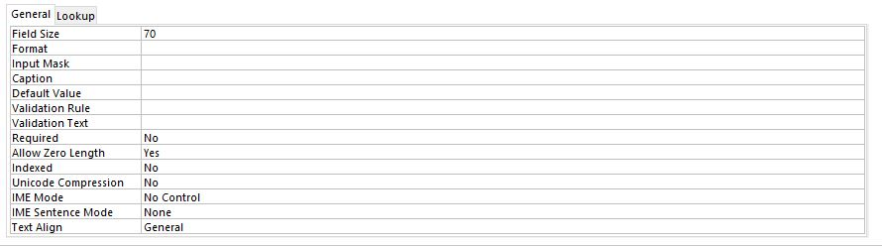

#### Number of courts

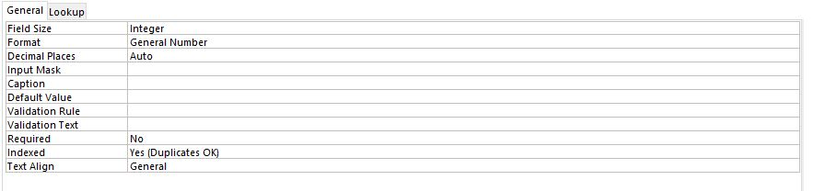

#### IDVen

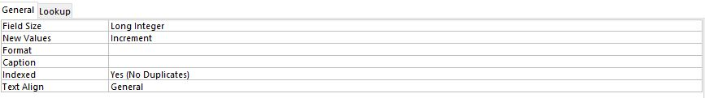

# 

# Task 3

## A Navigation

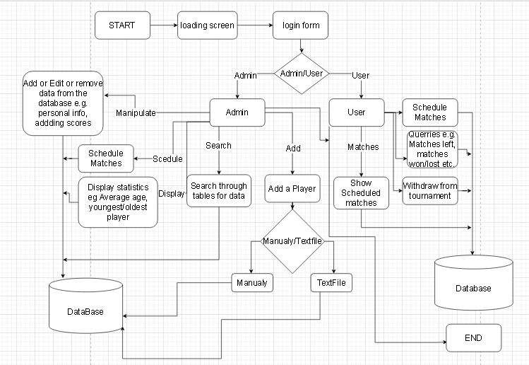

## B GUI

### Login

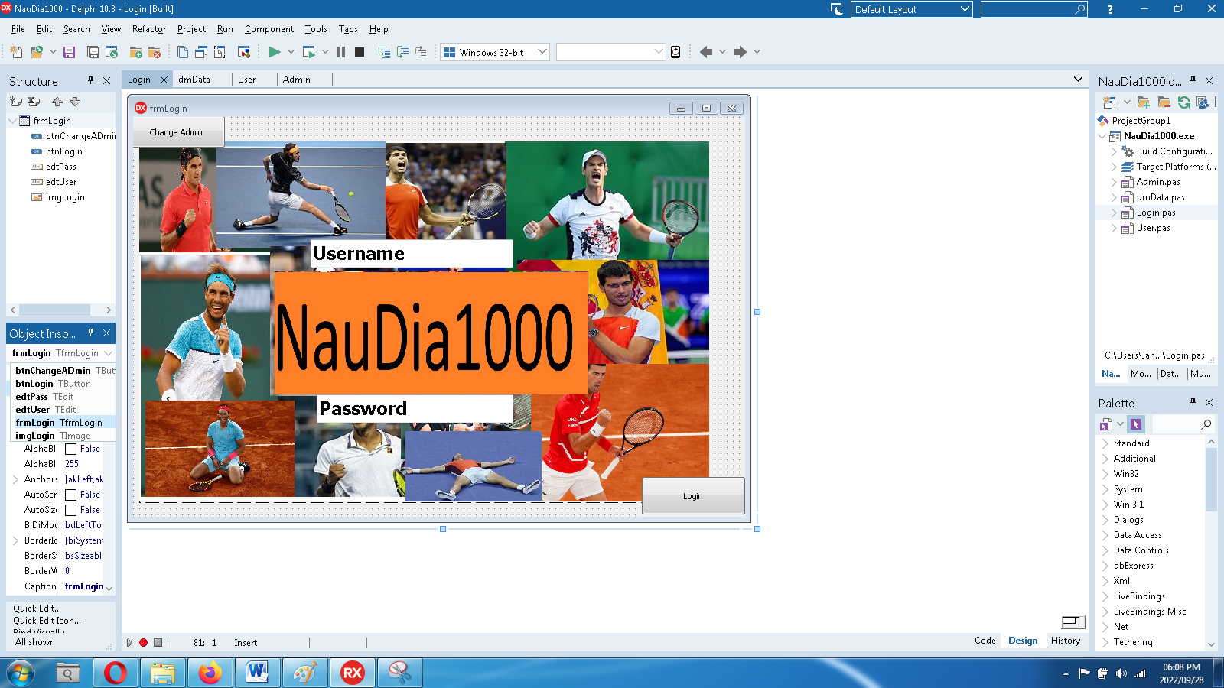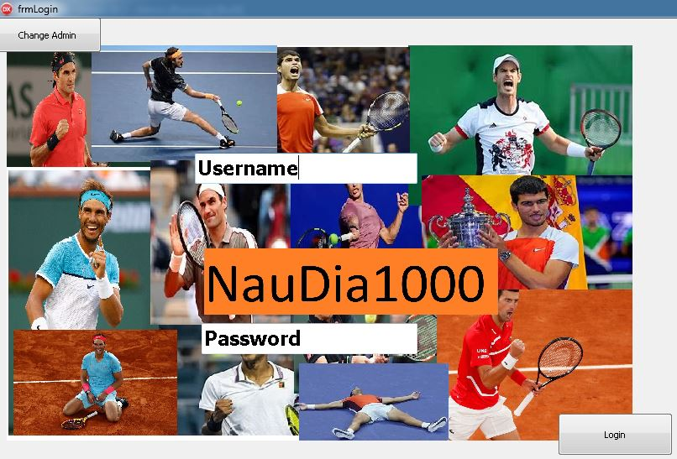

4

6

5

3

2

1

A

### User

### 

B

18

17

16

15

14

13

12

11

10

9

8

7

6

5

4

3

2

1

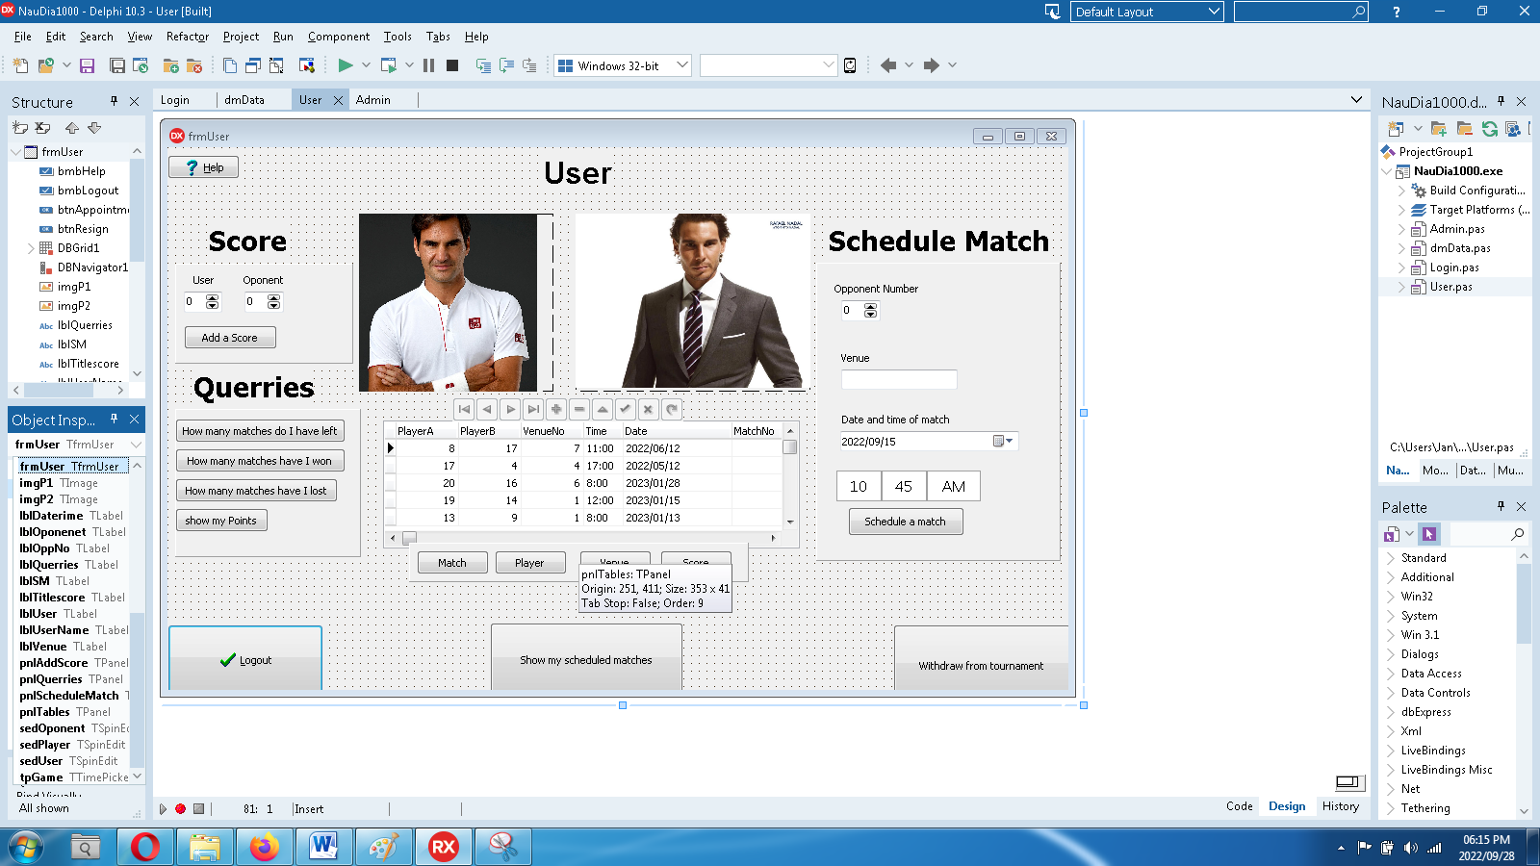

38

37

36

35

34

33

32

31

30

29

28

27

26

25

24

23

22

21

20

19

### Admin

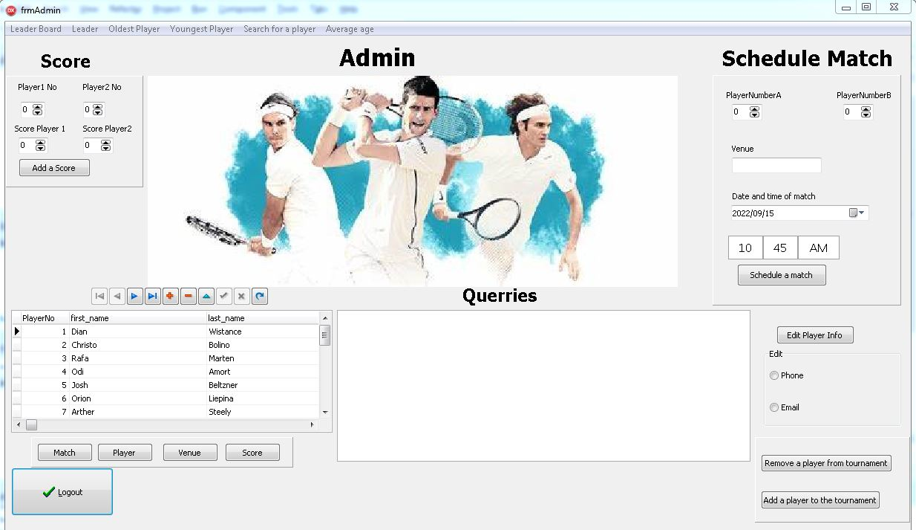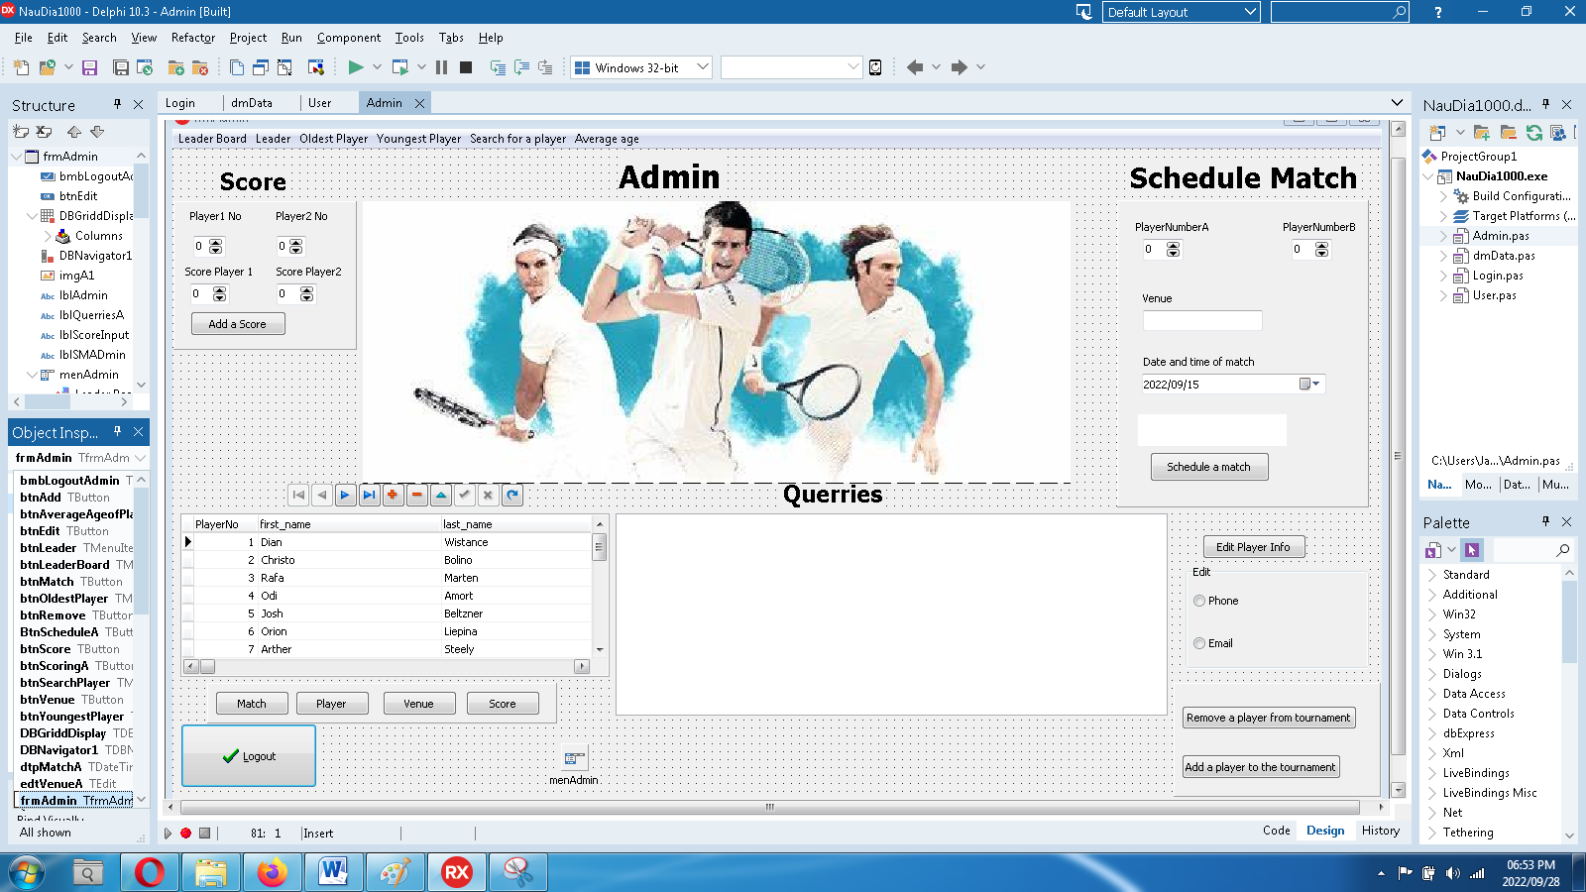

19

18

17

16

15

14

13

12

11

10

9

8

7

6

5

4

3

2

1

C

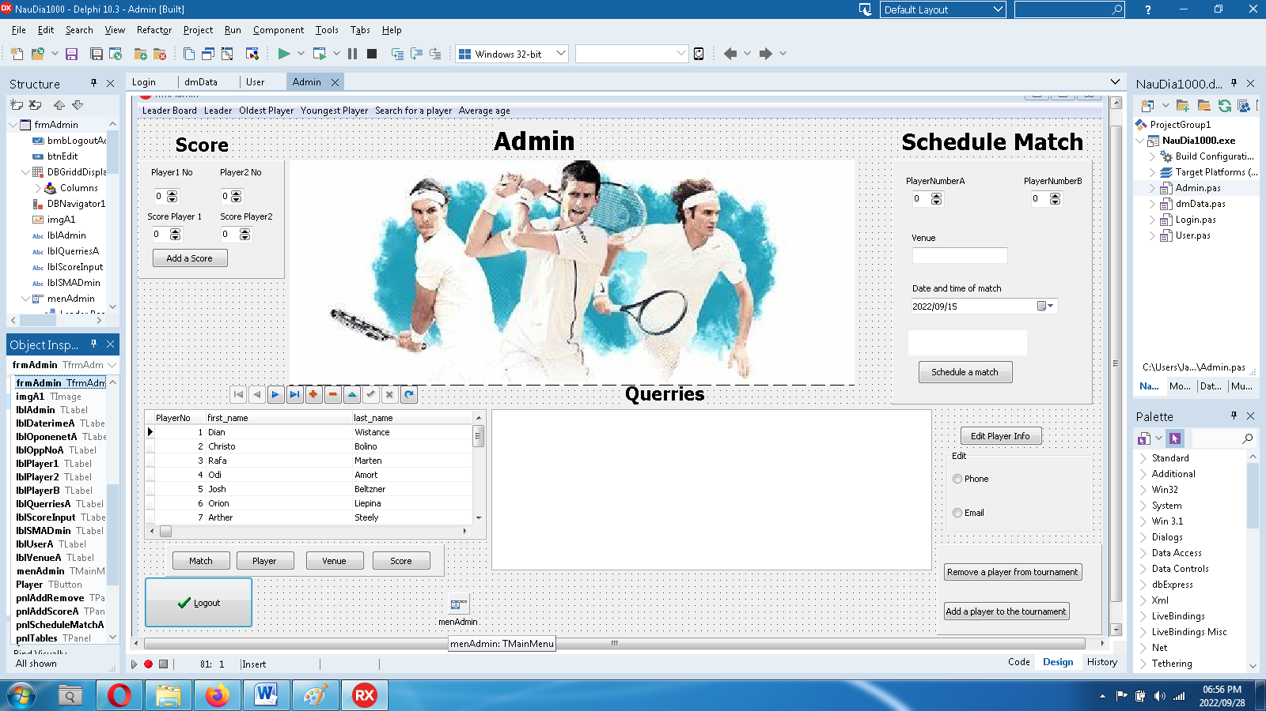

37

36

35

34

33

32

31

30

29

28

27

26

25

24

23

22

21

20

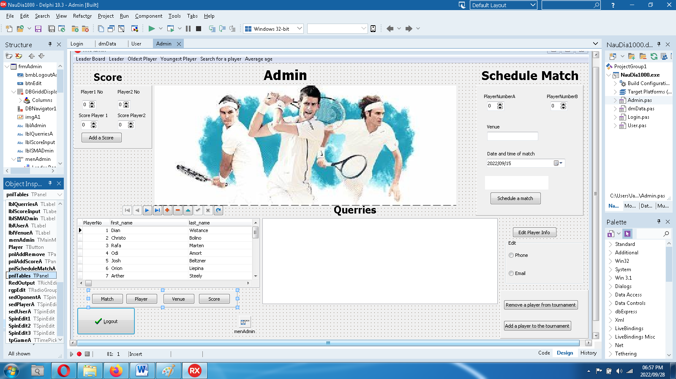

47

46

45

44

43

42

41

40

39

38

## IPO tables

# 

# Task 4

## Variables A

Check IPO

## Texfiles B

Players will be added by the use of a textfile which is refrenced as automaticaly added or it can be added manually. All the players details will be written in the textfile and extracted when adding a new player

## Arrays C

Arrays will be used to store the users Password and Username.Two corresponding Arrays will be used where one contains the Username and the other contains the password.New Users can be added with their new usernames and their given password.When Logging on th program will check if the Username Corresponds with the Password if it does the User Form will be shown of that specific user. Same principle with the Admin